Sven Petersen's C64-Keyboard-Controller-Kernal-Switch
https://github.com/svenpetersen1965/C64-Keyboard-Controlled-Kernal-Switch
Jaystonian's 6522/6526 Version for VIC-20, C64, C128

I redesigned Sven's microcontroller board for higher compatibility. It originally only fit the C64 keyboard 20-SIP header connector, and some boards required other modifications. It resets the system after selecting different regions of an EPROM (such as the KERNAL) by selecting the higher address lines using the Restore key and a number. It also allows for “shortboard” eprom selecting, since BASIC and KERNAL were combined in these models, with a solderjumper to tell the microcontroller.

It made sense to make it for the 40-DIP socket instead, so any system using the identical keyboard array can use the same switch. My idea is this can also be used to select configurations of the VIC-20's memory map, or different ROMs in different sockets on the C128 (KERNALs, BASICs, Internal EPROM socket). Also available on the C128 are data lines indicating 40/80 column mode and 64/128 mode. The 3 digital outputs of this switchboard provide a binary 0-7 (000-111, digital lines A, B and C). The solderjumper for shortboards in my design is called JP1, found on the bottom. I didn't include the JTAG connector or the full parts for the serial connection, although pins are exposed.

Please read and re-read instructions until steps are clear to you. Review the notes at the end of this document for advice on finding /RESTORE and /EXROM locations for your device model.

The six solder through-holes along the top end (between Pin 1 and Pin 40) are for /RESTORE, /EXROM, Power LED, and A B C. The serial connection straddles Pin 20 and Pin 21 (lower end); pins are 5V, /RESET, Tx, Rx and GND, respectively. Pin 1 (square pad) is GND. For the JTAG, 5V /RESET and GND are shared from serial, while MISO MOSI and SCK (respectively) are exposed as solderpads on the bottom, with MISO closest to Pin 40. For the most part, you will never need these.

We can use line A connected to the highest address line of a 27128 (16kb eprom) to select low/high 8kb for standard kernal or another, or the highest address line of a 27256 (32kb) for low/high 16kb regions. Or A and B for four, or A B C for eight. Hopefully this is not new information. This leads to multiple EPROMs, where C can be a low/high for the “Internal” socket, and A and B for kernal socket(s), and B for basic socket(s). This can provide a wider range of options for selecting EPROM regions.

For the more talented, you may choose to implement a selector circuit to configure eight completely different modes of any configuration for multiple EPROMs, enable memory expansions, toggle CPU speed... your imagination is the limit!

TOOLS NEEDED:
- Soldering iron
- Wire stripper (or whatever tool you are comfortable doing this with, without damaging the wire)
- Wire cutters
- Digital Multi Meter (DMM) or continuity tester

CONSUMABLES
- Solder and flux
- Some wire, 20ga to 26ga should be fine, solid or stranded, copper or not, shielded or not, but insulated always. If shielded, then be sure to ground the shielding and that it is not electrically connected.
INSTALLATION

- Identify and locate the MOS 6522 or MOS 6526 40-pin IC chip responsible for your keyboard. This is typically U1 in 64/128, UAB1 or UDE8 (E) or UAB3 (CR) in VIC-20.

- If this IC is not socketed, please de-solder it and then install a socket.

- If you are installing this in a C64 shortboard (Rev 250469), then solder closed JP1 on the bottom. This is /SHORTBRD input in Sven's PDF, aka solderjumper “CP1”.

- Locate the /RESTORE line on the motherboard and its distance to Pin 1 of the keyboard IC socket and then cut a wire long enough to reach, giving you an extra inch or two to trim later if necessary. Trim 1/8-inch of insulation from the wire and solder to the top-left through-hole of the switchboard.

- Locate the /EXROM line on the motherboard and do the same as step 3 above, cutting a wire long enough, trim, then solder to the through-hole next to /RESTORE. This can be omitted on the VIC-20.

- Optionally you may wire the Power LED directly to the third hole (anode of LED), which is current-limited by a 330-Ohm resistor on board, and then ground the LED's cathode. The switcher will flash this LED depending on modes. This is called RESIO in Sven's PDF.

- The last three holes, which fits a 1x03 0.1” pitch (2.54mm) header, are A B C. For most users, you will have a single EPROM and ABC will go to A13, A14 and A15 of a 27512 for selecting one of eight 8KB regions, or you will be using shortboard mode (please review Sven's documentation for this). Or A15, A16 and A17 for 32KB regions of a 27c020 in a 32-pin socket. Or use your imagination!

- Install switch board into socket with respect to “Pin 1 notch”, do not install backwards. The board has a socket with a notch on one end which should match the location of the socket notch underneath. Ensure your soldered wires do not contact anything else connected to the motherboard.

- Solder /RESTORE and /EXROM wires to their respective locations on the motherboard. Ensure they are not soldered to more than one pin or location (resistor legs, vias, etc) and trim them short.

- Install the 6522 or 6526 IC on top of the switch board, paying attention to the location of the Pin 1 notch.

USAGE

Please review Sven's original documentation. However, I will summarize:

While computer is ON...

- Holding RESTORE key for 1.5 to 3.0 seconds, you get a NORMAL RESET.
- Holding RESTORE ket for longer than 3.0 seconds, UNSTOPPABLE RESET.
- RESTORE + 0 selects 000 KERNAL and disables the scanning for improved compatibility (for diagnostic cartridges, for example)
- RESTORE + # (ie., 1 to 8, or 1 to 7 in shortboards) selects 000 to 111 KERNAL

NOTES

- VIC-20:
  - /RESTORE can be found as the north leg of R1, south of U1 (whichever is not 5V)
  - /EXROM does not exist, omit connection.
  - Some of the number keys do not respond with the restore-reset and the ones that do just tend to randomly toggle the outputs and succeed a reset. No troubles if just switching two ROMs.

- VIC-20E:
  - /RESTORE can be found as the north leg of R26, west of UD6
  - /EXROM does not exist, omit connection.

- VIC-20CR:
  - /RESTORE can be found as R16 south of the keyboard header. You will need to continuity test to find which leg, from Pin 3 of the keyboard header.
  - /EXROM does not exist, omit connection.

- C64 Rev326298:
  - /RESTORE can be found as the east leg of R41, along the west side of the board.
  - /EXROM can be found on Pin 23 of U17. Continuity exploration recommended for a nearby through-hole between U17 and the SID chip.

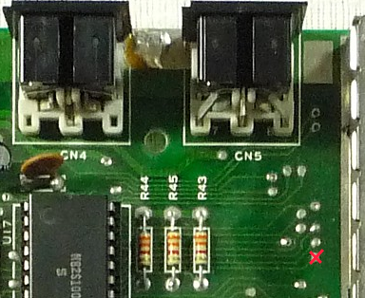
- C64 Rev250407:
  - /RESTORE can be found as the east leg of R41, near the lower left corner of the board.
  - /EXROM can be found south of the A/V Port, next to the RFM shield.

- C64 Rev250425:
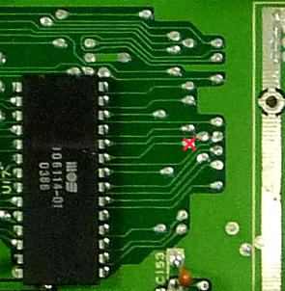
  - /RESTORE can be found as the east leg of R41, near the bottom-left corner of the board.
  - /EXROM can be found right of U17

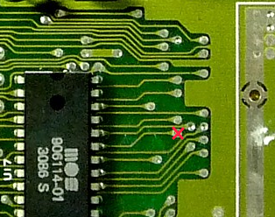
- C64 Rev250466:
  - /RESTORE can be found as the east leg of R41, near the
lower left corner of the board.
  - /EXROM can be found east of U17

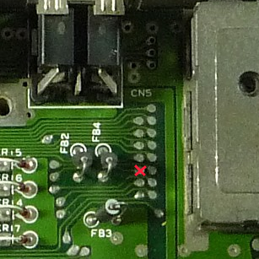
- C64 Rev250469:
  - /RESTORE can be found immediately to the right of Keyboard Header pin 3.
  - /EXROM can be found west of the RFM

- C128, 128D:
  - /RESTORE is nearby U1, either immediately south near its Pin 21 (which would be beneath the installed switchboard), or the east leg of R9.
  - /EXROM is to the left of U7, about 1/4-inch (~6mm) southwest of R27.
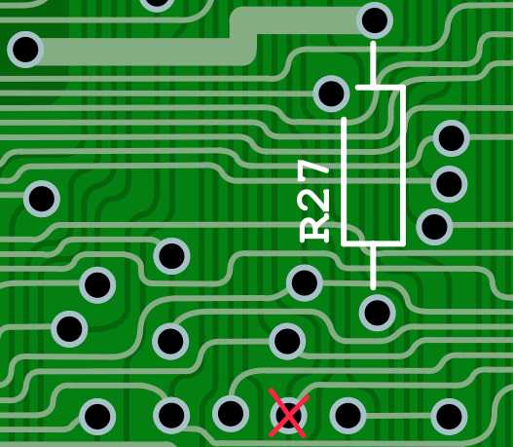
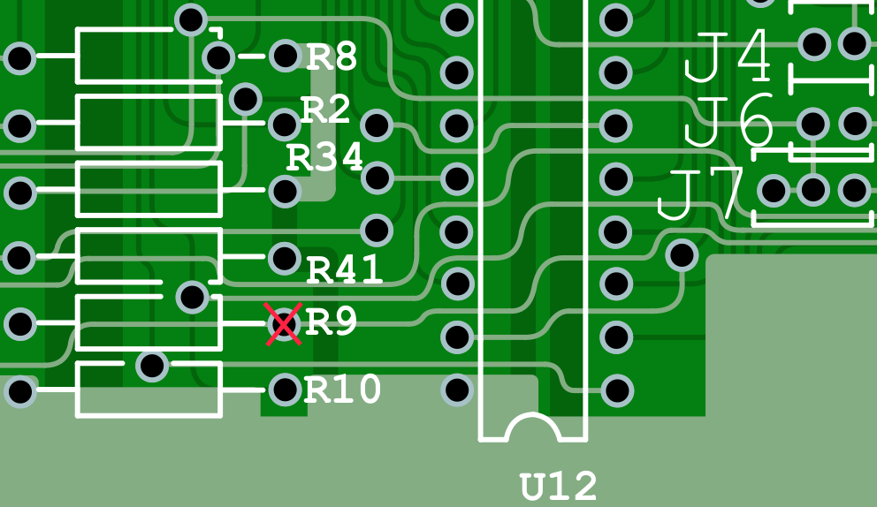

- C128DCR: There are several revisions of this Cost Reduced model. I have an earlier model that is a “full-size board.” The simplest way for you to find exposed through-holes, instead of IC legs, is with a continuity tester using the leg pin as a starting point and then explore.
  - /RESTORE can be found on Pin 9 of U16
  - /EXROM can be found on Pin 46 of U7

